Supplementary information
Mixture toxicity of zinc oxide nanoparticle and chemicals with different mode of action upon Vibrio fischeri
Supplementary information includes the following:
Total pages: 8; Total table: 1; Total figures: 5

Table S1 Detail information of test chemicals

Fig. S1 The setting of test groups in 96-well microplate

Fig. S2 Comparison of dose response curves in acute toxicity test at equitoxic ratios derived from determined data and predicted data by CA and IA models. (a1-a9) nZnO-chemicals, (b1-b9) Zn²⁺-chemicals, Obs stands for observation

Fig. S3 Comparison of dose response curves in acute toxicity test at non-equitoxic ratios derived from determined data and predicted data by CA and IA models. (a1-a11) nZnO-SMZ, (b1-b11) nZnO-AL, Obs stands for observation

Fig. S4 Comparison of dose response curves in chronic toxicity test at equitoxic ratios derived from determined data and predicted data by CA and IA models. (a1-a9) nZnO-chemicals, (b1-b9) Zn²⁺-chemicals, Obs stands for observation

Fig. S5 Comparison of dose response curves in chronic toxicity test at non-equitoxic ratios derived from determined data and predicted data by CA and IA models. (a1-a11) nZnO-SMZ, (b1-b11) nZnO-AL, Obs stands for observation

Table S1 Detail information of 9 chemicals
No | Chemical | Abbreviation | CAS No. | Chemical formula | Chemical structure
1 | Sulfapyridine | SPY | 144-83-2 | C₁₁H₁₁N₃O₂S | 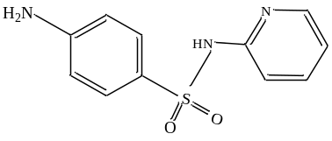
2 | Sulfadiazine | SD | 68-35-9 | C₁₀H₁₀N₄O₂S | 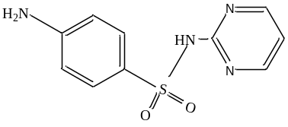
3 | Sulfamethoxazole | SMZ | 723-46-6 | C₁₀H₁₁N₃O₃S | 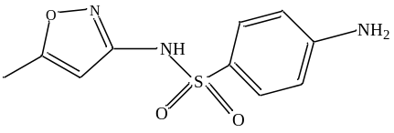
4 | Oxytetracycline hydrochloride | OTC | 2058-46-0 | C₂₂H₂₅ClN₂O₉ | 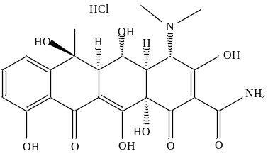
5 | Tetracycline hydrochloride | TTC | 64-75-5 | C₂₂H₂₅ClN₂O₈ | 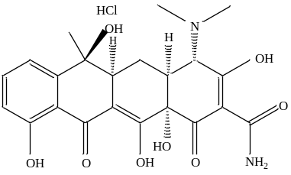
6 | Aniline | AL | 62-53-3 | C₆H₇N | 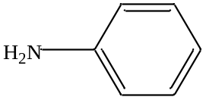
7 | 2-Nitroaniline | NAL | 88-74-4 | C₆H₆N₂O₂ | 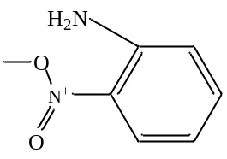
8 | p-Toluidine | TD | 106-49-0 | C₇H₉N | 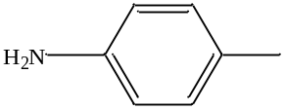
9 | Hydroquinone | HQ | 123-31-9 | C₆H₆O₂ | 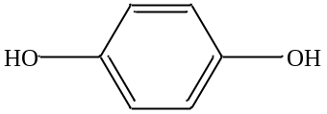

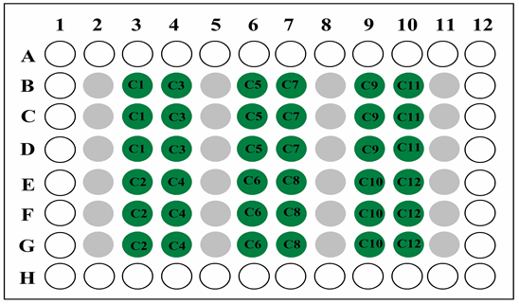

Fig. S1 The setting of test groups in 96-well microplate (white circles present the edge wells; gray circles denote the control and green circles are the test wells)

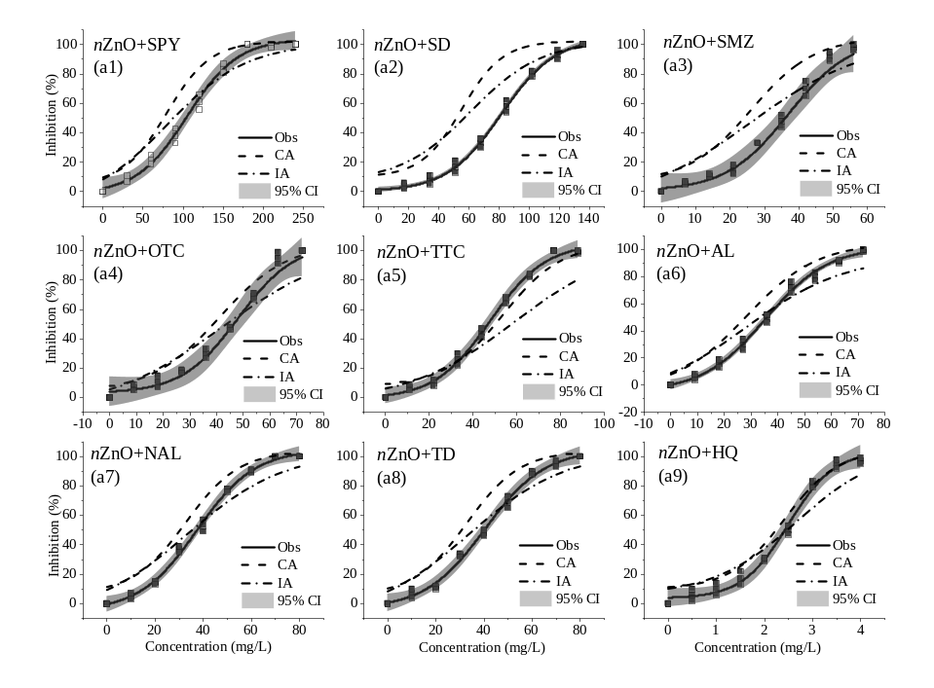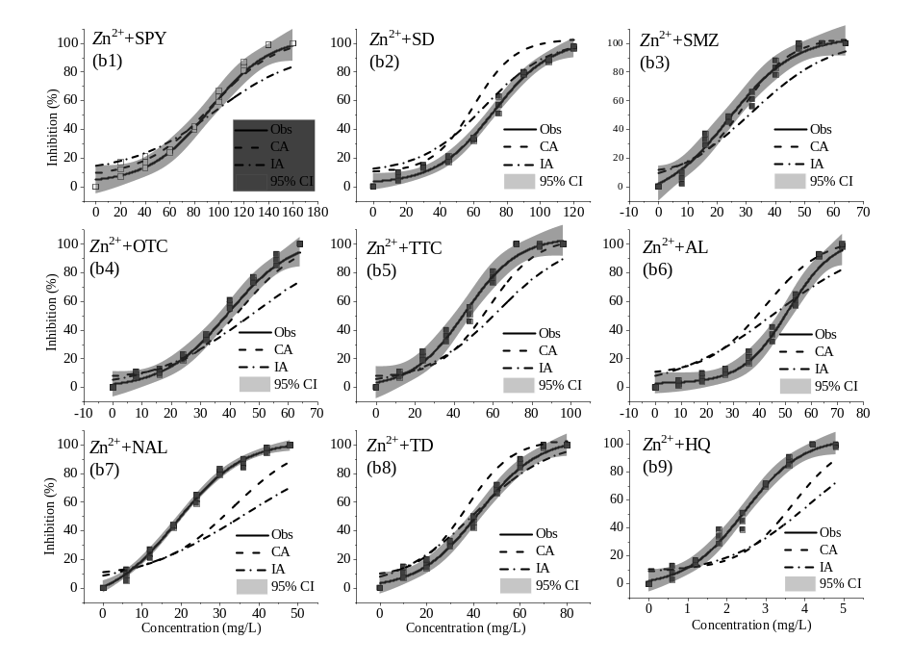
Fig. S2 Comparison of dose response curves in acute toxicity test at equitoxic ratios derived from determined data and predicted data by CA and IA models. (a1-a9) nZnO-chemicals, (b1-b9) Zn²⁺-chemicals, Obs stands for observation

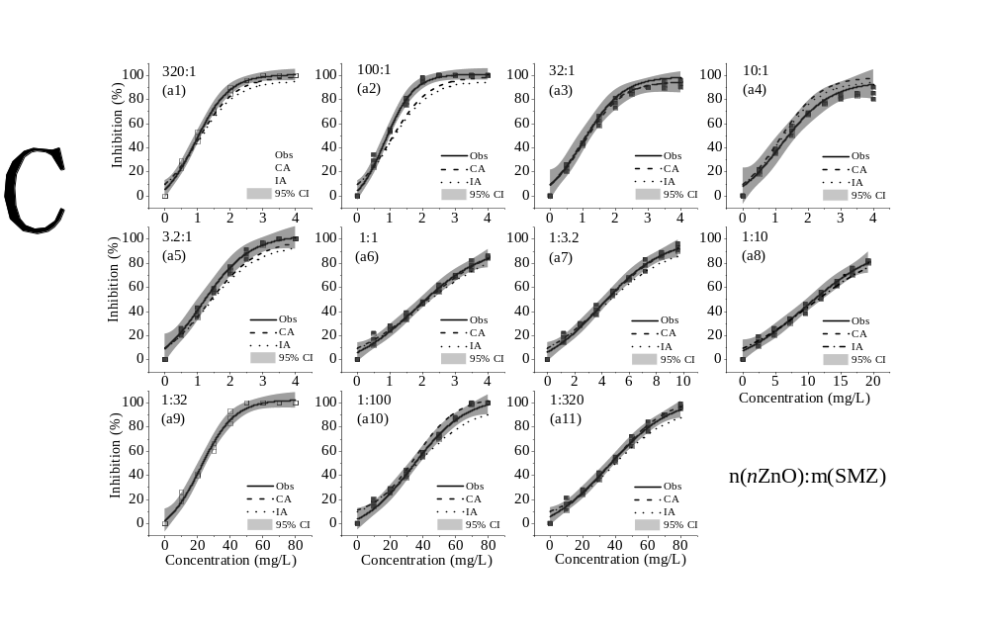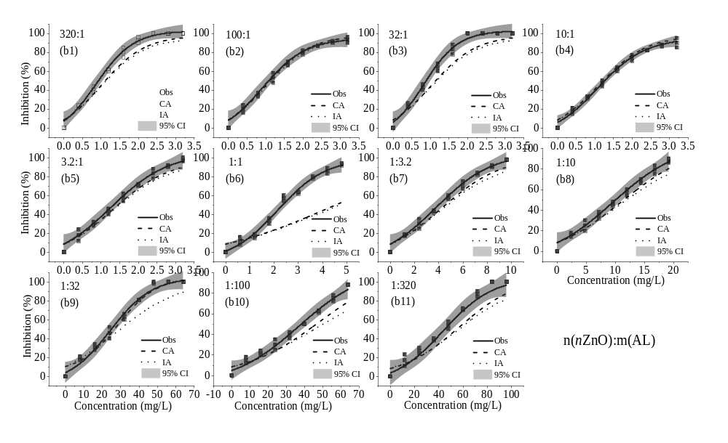
Fig. S3 Comparison of dose response curves in acute toxicity test at non-equitoxic ratios derived from determined data and predicted data by CA and IA models. (a1-a11) nZnO-SMZ, (b1-b11) nZnO-AL, Obs stands for observation

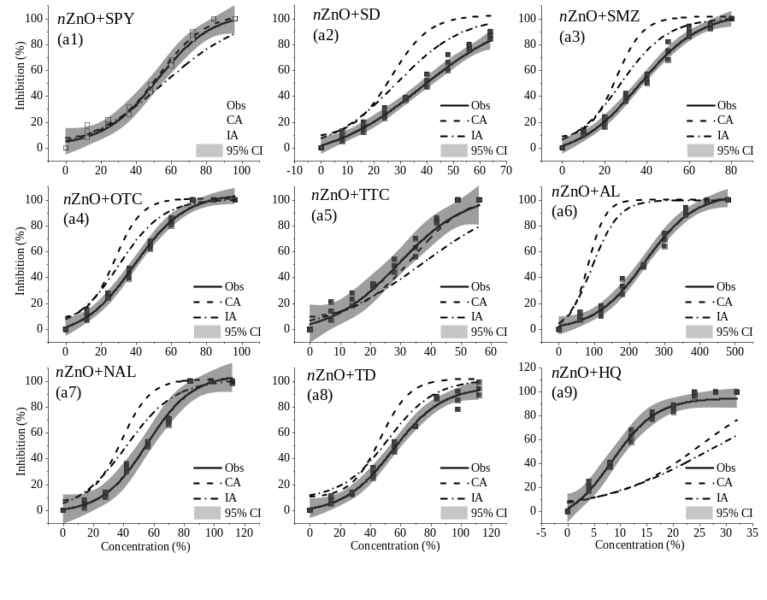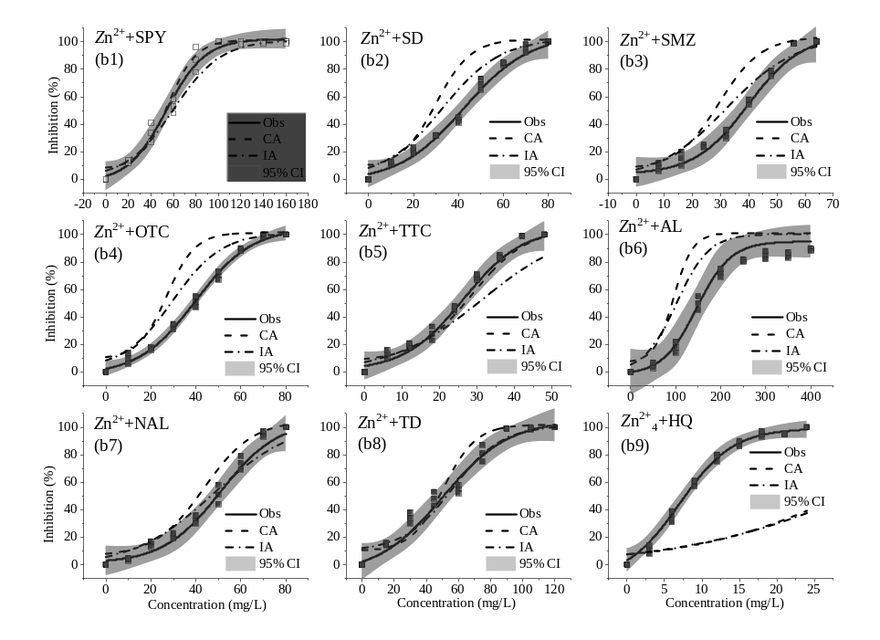
Fig. S4 Comparison of dose response curves in chronic toxicity test at equitoxic ratios derived from determined data and predicted data by CA and IA models. (a1-a9) nZnO-chemicals, (b1-b9) Zn²⁺-chemicals, Obs stands for observation

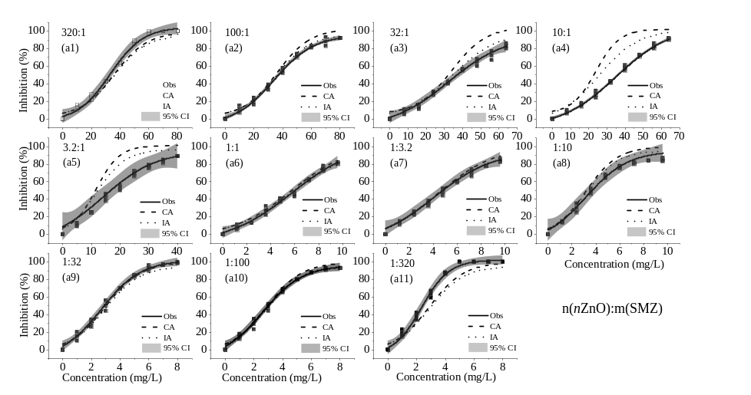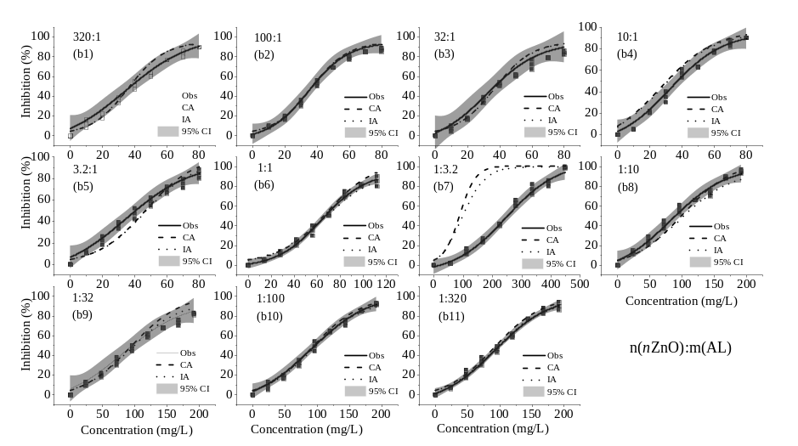
Fig. S5 Comparison of dose response curves in chronic toxicity test at non-equitoxic ratios derived from determined data and predicted data by CA and IA models. (a1-a11) nZnO-SMZ, (b1-b11) nZnO-AL, Obs stands for observation

